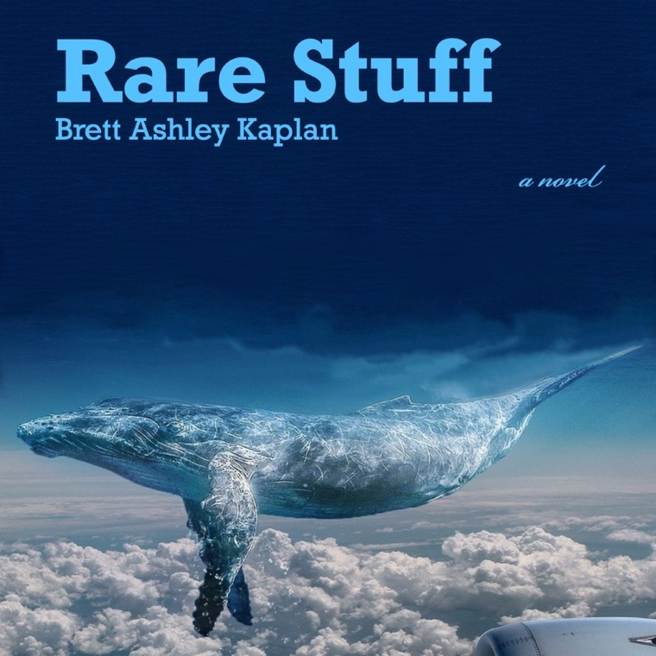

For more information, contact:
Brenda Thompson, 512-461-5644
brenda@brendathompson.com

12 July, 2022

Interlocking stories, mysterious clues,
Yiddish-speaking whales in debut novel Rare Stuff

URBANA-CHAMPAIGN—The new novel Rare Stuff takes readers on a multilayered, mysterious journey through a series of interlocking clues. An intriguing search for a missing person moves through real and magically real universes in New York, Chicago, and glass houses under the sea constructed by Yiddish-speaking whales desperate to save our endangered planet. The unusual story touches on grief, love, and precarity leavened with hope.

Set in the mid-90s, Rare Stuff tells the story of Sidney Zimmerman, a slightly lost white-Jewish photographer working on an infinite series of portraits of interracial couples. After the death of her father, novelist/rare book librarian Aaron, Sid and her Black-Jewish Guadeloupean Melville scholar boyfriend follow a series of wacky clues Aaron irritatingly left in a suitcase to lead them to the solution of the mysterious disappearance of Sid’s whale-enthusiast mother 18 years earlier.

Aaron also left a manuscript, included as a novel-within-the-novel, set in an underwater universe and sporting his wild ideas that his wife had been adopted by whales.

“Yiddish-speaking whales, a suitcase packed with secrets, and one young woman’s desperate attempt to find answers.
When Sidney Zimmerman’s father, Aaron, dies, she doesn't feel any longed-for closure. Instead, cleaning out his apartment, she uncovers a suitcase hidden in the back of the closet and full of such seemingly random items as a red high-heeled shoe, a paperweight, and a photograph of a man in a fedora, and, on his desk, the manuscript of the unpublished novel Slobgollion. The items in the suitcase turn out to be cryptic clues about Sid’s mother, Dorothy, an amateur cetologist—a scientist who studies whales—who disappeared when Sid was a child. Sid’s search for answers about what happened to her mother spurs the novel along. Things fall into place as Sid and her boyfriend, André, follow Aaron’s mysterious breadcrumbs, and people spring up to help as if placed there by magic: “We’ve been scripted, we’re in one of dad’s books, surely, yet another person hails us as if he jumped out of the suitcase, breathing.” The novel alternates among Sid’s perspective, the long-suffering André’s perspective, and chapters from Aaron’s unpublished manuscript featuring Yiddish-speaking whales trying to save the world from environmental collapse. Kaplan packs a lot into her novel, from cautionary tales about conservation to…discussions on interracial relationships, police brutality, and genocide. And while the novel’s ambitious scope could easily have been its downfall, it's saved by descriptions of tender longing for connection and purpose, particularly realized in André’s chapters, as well as a soft, magical tone.
A dreamy story with surprising emotional resonance.” —Kirkus Reviews

“In this richly imagined novel, Brett Ashley Kaplan skillfully and playfully moves between points of view, incorporating journal entries, novel excerpts, book reviews, and nuanced environmental commentary. Following a vivid cast of characters which includes a young photographer documenting interracial couples, a Guadeloupean Jewish Melville scholar, a disappeared amateur cetologist and even Yiddish speaking whales, this inventive novel takes us on a wild adventure from the urban streets of New York’s East Village to the depths of the sea. Tender, confident and bold, Rare stuff brims with vitality.” –Ayelet Tsabari, author of The Art of Leaving and The Best Place on Earth

“Like the overstuffed suitcase that Sid Zimmerman finds of her dead father’s stashed-away arcana, Rare Stuff holds several things at once—an homage to Melville, a paean to New York City past and present, and, at the same time, a cri de coeur for preserving the natural life of our planet.” —David Wright Faladé, author of Black Cloud Rising and Fire on the Beach: Recovering the Lost Story of Richard Etheridge and the Pea Island Lifesavers.

“With Inherited clues stuffed in an old suitcase, Brett Ashley Kaplan takes the readers into a painfully joyful journey of racism, survival, loss and love. Skillfully and with much sensitivity, Rare Stuff connects bloody history to the most burning issues of our times. The biggest achievement of this novel, with the help of Yiddish-speaking whales, is that it 'gives history an optimistic twist.' A hopeful twist much needed these days!" --Sayed Kashua, author of Dancing Arabs, Let it Be Morning, Second Person Singular, and Track Changes

Rare Stuff is a beautiful, bewitching novel built on interlocking stories: a cosmopolitan photographer named Sid, grieving the death of her father, finds an unfinished manuscript and a suitcase full of clues about the long-ago disappearance of her mother. We follow Sid on a breathless search for her mother, and we dive deep into her father’s unfinished adventure tale, in which Yiddish-speaking whales and a bold teenage girl set out to save the world. By the book’s close, I had become friends with its characters: I wanted to jump into fast-paced conversations about life and literature with Sid, Andre, Dorothy, Aaron, and Sol, and I wanted to take part in the extraordinary multi-generational (and multi-species) community they built together. Rare Stuff tells the story of the very best adventure: the quest we all undertake to understand and care for our parents, our children, and the world we share together. –Jamie Jones, author of Rendered Obsolete: The Afterlife of US Whaling in the Petroleum Age

Rare Stuff is the first novel by Brett Ashley Kaplan, author of three non-fiction books on topics related to the Holocaust and Jewish-American literature. She is director of the Initiative in Holocaust, Genocide, and Memory Studies at the University of Illinois, Urbana-Champaign, where she is a professor and director of graduate studies for the Program in Comparative and World Literature.

Her writing has been published in Salon, Haaretz, The Conversation, As It Ought To Be Magazine, Contemporary Literature, and The Jewish Review of Books among others.

Named for Lady Brett Ashley in The Sun Also Rises, she is at work on a second novel, Vandervelde Downs, about the recovery of Nazi-looted objects found in a Vietnamese refugee center in provincial England.

Rare Stuff is published by Spuyten Duyvil and will be available beginning August 1, 2022. All proceeds from Rare Stuff will benefit Whale and Dolphin Conservation USA.

For more information, go to www.brettashleykaplan.com or to the author’s page on Facebook.

###

